Stock Price and Trading Volume Anomalies of Aneka Tambang Tbk. (ANTM): A Daily Data and News-Based Contextual Analysis, 2019–2025

Prana Ugiana Gio^{1*}, Abdillah Arif Nasution², Robert Kurniawan³, Khairul Ali Hutasuhut⁴, Agung Wahyudhi Atmanegara⁵, Haryaji Catur Putera Hasman⁶, Vicky Rosalia⁷, Rizki Syahputra⁸

Department of Mathematics, Universitas Sumatera Utara, 20155 Medan, Indonesia¹
Department of Accounting, Universitas Sumatera Utara, 20155 Medan, Indonesia^{2,4,5,6,7}
Department of Statistical Computing, Politeknik Statistika STIS, 13330 Bidaracina, Jakarta, Indonesia³
Department of Accounting, Politeknik Negeri Medan, Indonesia⁸

Corresponding Author: prana@usu.ac.id*

Abstract
Keywords:

3. Results

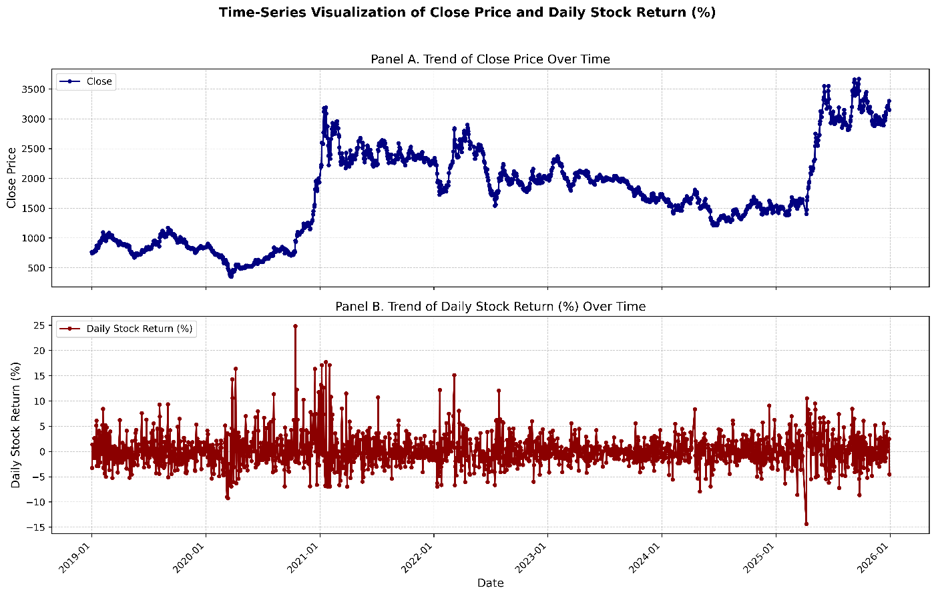
Figure 3.1. Time-Series Trends in Closing Price and Daily Stock Return of Aneka Tambang Tbk. (ANTM)

Table 3.1. Annual Stock Price Performance of Aneka Tambang Tbk. (ANTM), 2019–2025
Year | Beginning-of-Year Stock Price | End-of-Year Stock Price | Annual Price Change | Annual Percentage Change (%)
2019: 1 Jan 2019-30 Dec 2019 | 765 | 840 | 75 | 9.8039
2020: 2 Jan 2020-30 Dec 2020 | 840 | 1935 | 1095 | 130.3571
2021: 4 Jan 2021-30 Dec 2021 | 2190 | 2250 | 60 | 2.7397
2022: 3 Jan 2022-30 Dec 2022 | 2340 | 1985 | -355 | -15.1709
2023: 2 Jan 2023-29 Dec 2023 | 1980 | 1705 | -275 | -13.8889
2024: 2 Jan 2024-30 Dec 2024 | 1735 | 1525 | -210 | -12.1037
2025: 2 Jan 2025-30 Dec 2025 | 1545 | 3150 | 1605 | 103.8835

Table 3.2. Frequency and Percentage Distribution of Daily Stock Return Direction by Year for Aneka Tambang Tbk. (ANTM)
Year | Daily Stock Return Direction | Frequency | Percentage
2019 | - | 123 | 47.86%
2019 | + | 106 | 41.25%
2019 | 0 | 28 | 10.89%
2020 | - | 111 | 45.87%
2020 | + | 109 | 45.04%
2020 | 0 | 22 | 9.09%
2021 | - | 130 | 52.63%
2021 | + | 102 | 41.30%
2021 | 0 | 15 | 6.07%
2022 | - | 131 | 53.25%
2022 | + | 97 | 39.43%
2022 | 0 | 18 | 7.32%
2023 | - | 115 | 48.12%
2023 | + | 94 | 39.33%
2023 | 0 | 30 | 12.55%
2024 | - | 116 | 48.95%
2024 | + | 103 | 43.46%
2024 | 0 | 18 | 7.59%
2025 | - | 102 | 43.22%
2025 | + | 124 | 52.54%
2025 | 0 | 10 | 4.24%

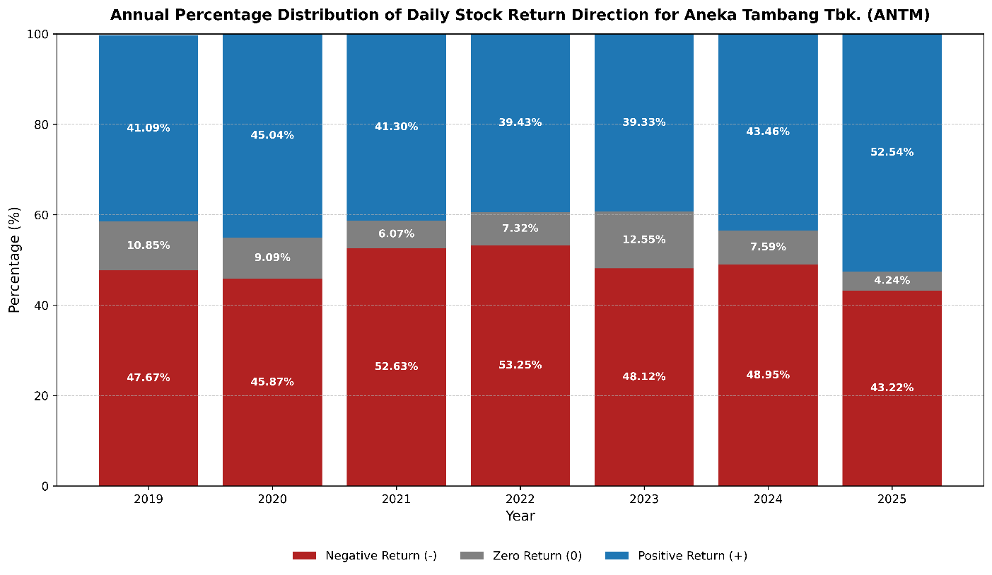
Figure 3.2. Annual Percentage Distribution of Daily Stock Return Direction for Aneka Tambang Tbk. (ANTM)

Table 3.3. Annual Distribution of Price Anomaly Events of Aneka Tambang Tbk. (ANTM)
Year | Price Anomaly Category | Frequency | Percentage
2019 | Sharp Price Decrease | 10 | 50.00%
2019 | Sharp Price Increase | 10 | 50.00%
2019 | Total | 20 | 100.00%
2020 | Sharp Price Decrease | 19 | 47.50%
2020 | Sharp Price Increase | 21 | 52.50%
2020 | Total | 40 | 100.00%
2021 | Sharp Price Decrease | 16 | 53.33%
2021 | Sharp Price Increase | 14 | 46.67%
2021 | Total | 30 | 100.00%
2022 | Sharp Price Decrease | 15 | 51.72%
2022 | Sharp Price Increase | 14 | 48.28%
2022 | Total | 29 | 100.00%
2023 | Sharp Price Decrease | 0 | 0.00%
2023 | Sharp Price Increase | 2 | 100.00%
2023 | Total | 2 | 100.00%
2024 | Sharp Price Decrease | 10 | 58.82%
2024 | Sharp Price Increase | 7 | 41.18%
2024 | Total | 17 | 100.00%
2025 | Sharp Price Decrease | 17 | 48.57%
2025 | Sharp Price Increase | 18 | 51.43%
2025 | Total | 35 | 100.00%

Table 3.4. Top 10 Price Anomaly Events Based on Absolute Daily Stock Return of Aneka Tambang Tbk. (ANTM)
Date | Year | Close | Daily Stock Return Direction | Daily Stock Return (%) | Absolute Return (%) | Price Anomaly Category
2020-10-14 | 2020 | 955 | + | 24.84 | 24.84 | Sharp Price Increase
2021-01-20 | 2021 | 3190 | + | 17.71 | 17.71 | Sharp Price Increase
2021-01-07 | 2021 | 2600 | + | 17.12 | 17.12 | Sharp Price Increase
2021-02-01 | 2021 | 2600 | + | 17.12 | 17.12 | Sharp Price Increase
2020-04-06 | 2020 | 540 | + | 16.38 | 16.38 | Sharp Price Increase
2020-12-16 | 2020 | 1815 | + | 16.35 | 16.35 | Sharp Price Increase
2022-03-07 | 2022 | 2820 | + | 15.1 | 15.1 | Sharp Price Increase
2025-04-08 | 2025 | 1400 | - | -14.37 | 14.37 | Sharp Price Decrease
2020-03-26 | 2020 | 416 | + | 14.29 | 14.29 | Sharp Price Increase
2021-01-04 | 2021 | 2190 | + | 13.18 | 13.18 | Sharp Price Increase

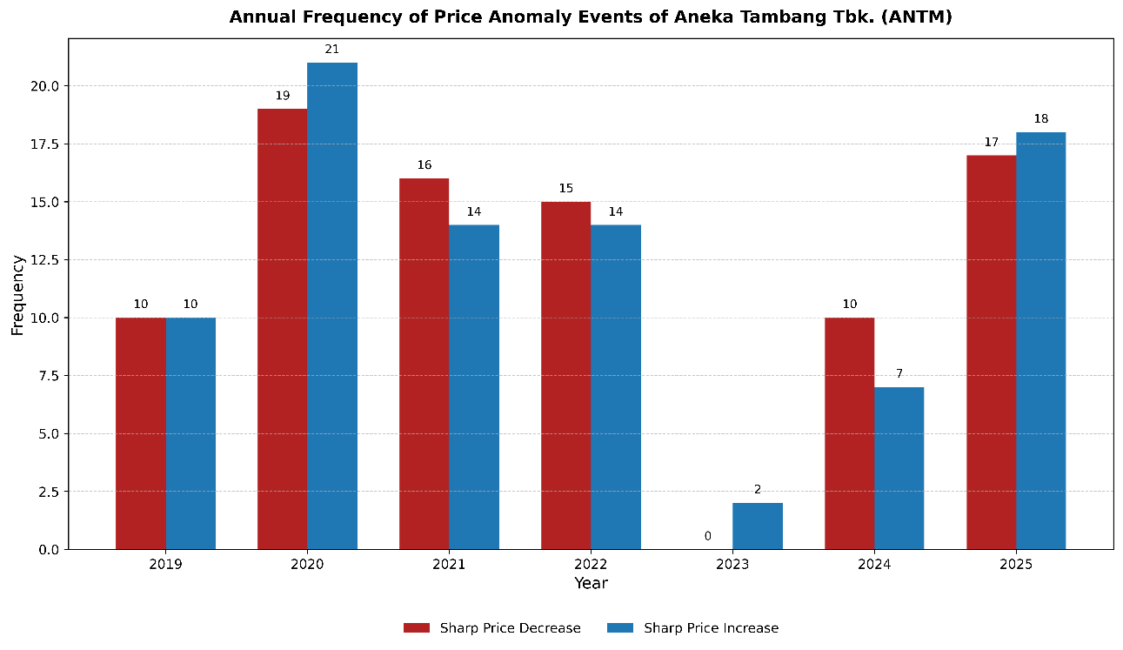
Figure 3.3. Annual Frequency Distribution of Price Anomaly Events of Aneka Tambang Tbk. (ANTM)

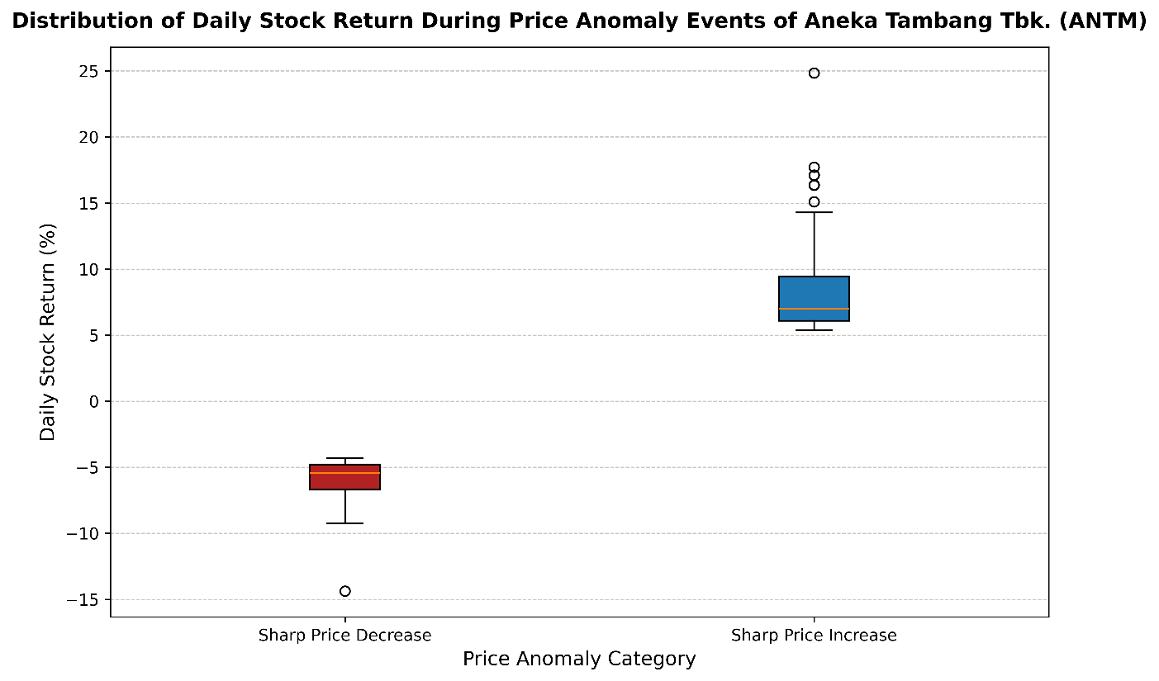
Figure 3.4. Boxplot of Daily Stock Return by Price Anomaly Category for Aneka Tambang Tbk. (ANTM)

Table 3.5. News-Based Contextual Analysis of Top 10 Price Anomaly Events of Aneka Tambang Tbk. (ANTM)

